Early Learning Assessment Bridge Document
Teacher Paper and Pencil Directions
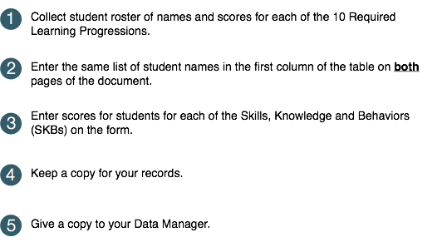
FALL/SPRING Data Collections

Write Same Student Names on Page 2 & 3 | Emotional Identification | Response to Distressed Peer | Separation from Familiar Adults | Seeking Emotional Support | Play/ Work with Peers | Social Behaviors | Rhyming Words | Syllables/ Onsets and Rimes/ Phonemes | Initial / Final / Medial Sounds | Adding/ Deleting/ Substituting Sounds | Purposes and Situations | Word Meanings
Copy Student Names From Page 2 | Word Relationships | Number Words | Object Counting | Number Concepts | Subitizing | Numeral Identification /Writing | Tool and Object Manipulation | Writing Tool Grasp | Safe and Unsafe Behaviors | Safety Rules | Ways Adults Help Keep Children Safe | Personal Care and Basic Health

